**Document Loaders in LangChain**

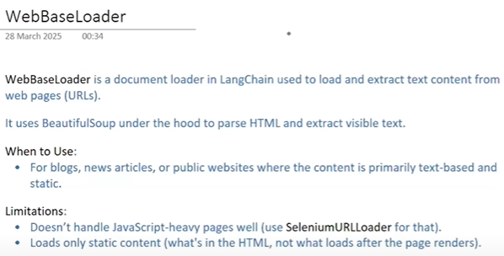

There are many document loader, we can make our own document loader

